**Virtual machine**

Experiment-1: Create a Virtual Machine with 1 vCPU, 2GB RAM and

15GB storage disk using a Type 2 Virtualization Software

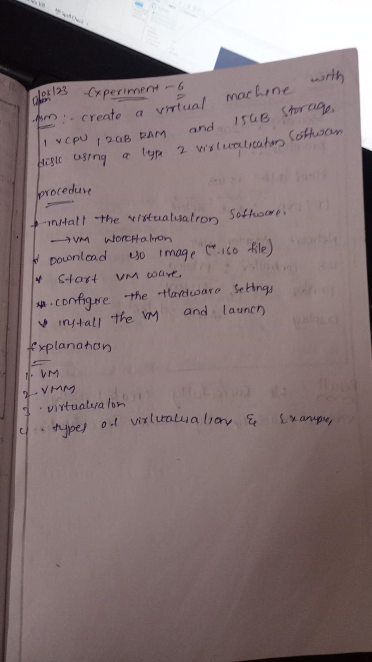

Output:-

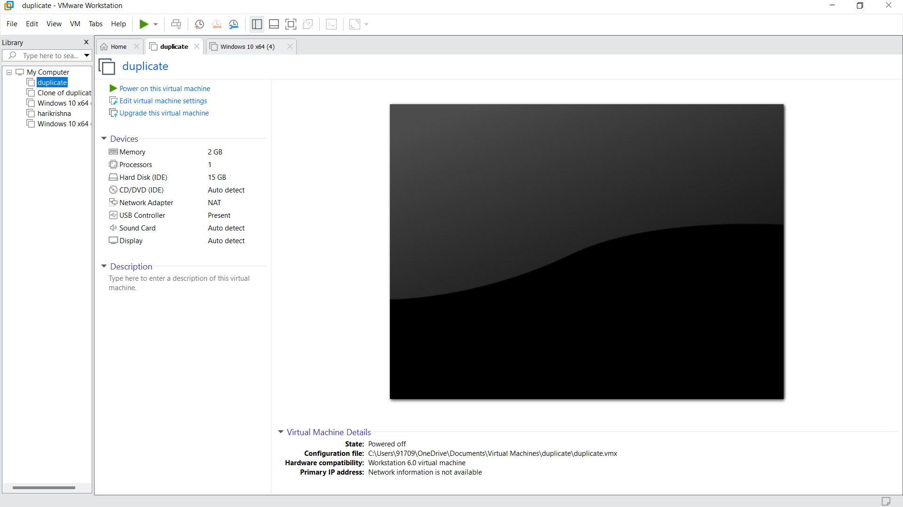

Experiment-2:Create a Virtual Hard Disk and allocate the storage using

VM ware Workstation

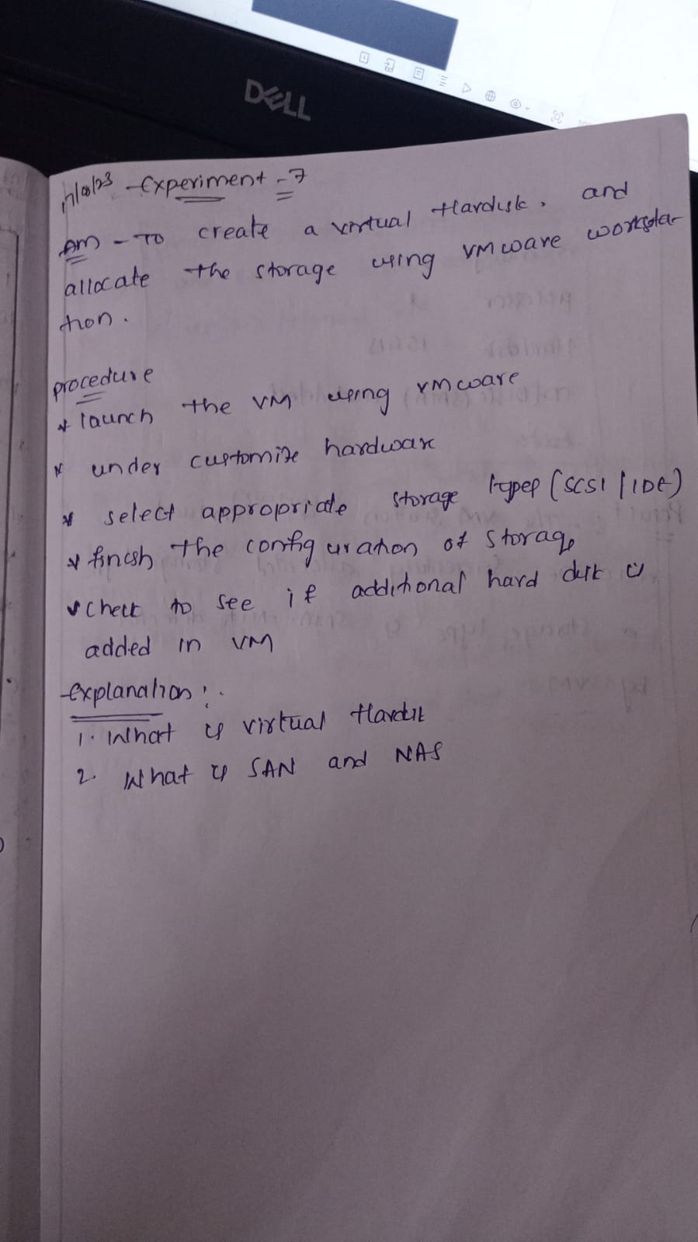

Out put:-

Experiment-3: Create a Snapshot and Cloning of a VM and Test it by

loading the Previous Version/Cloned VM

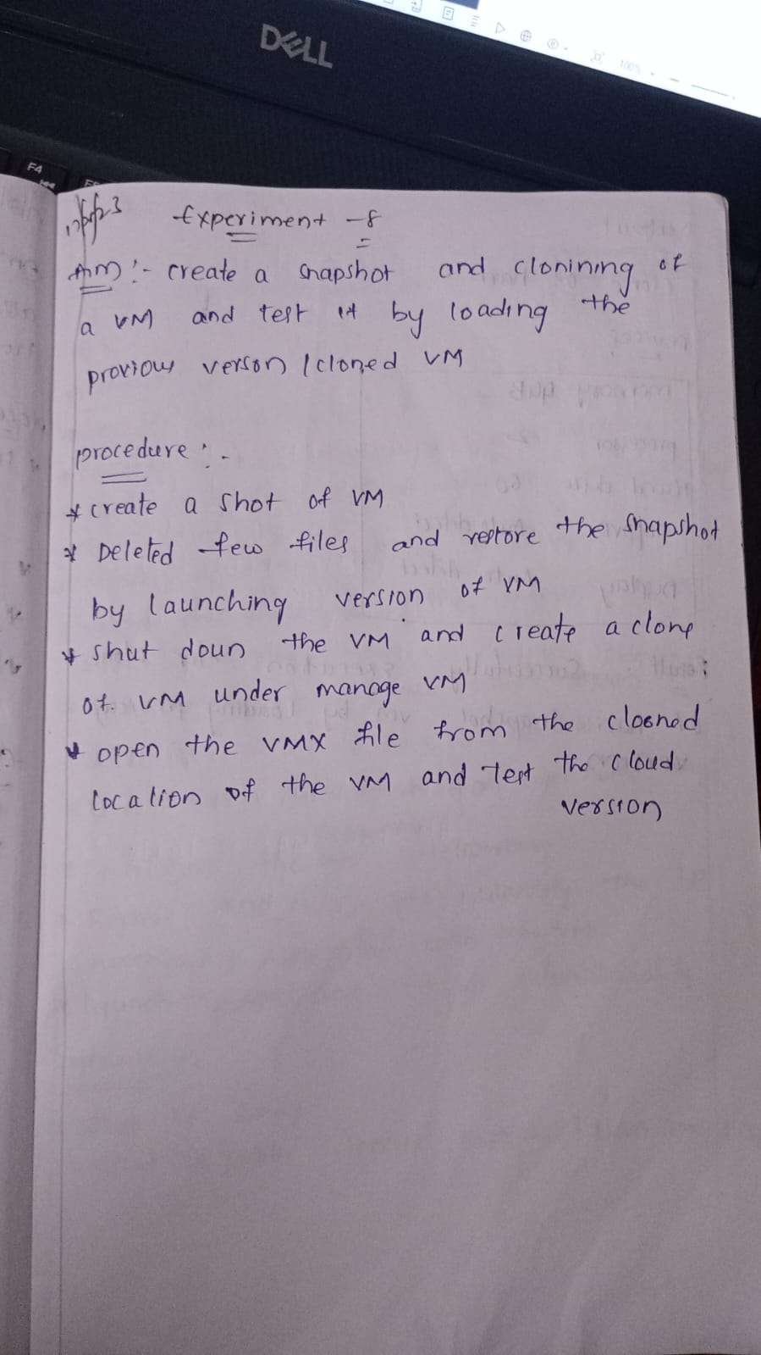

Output:-

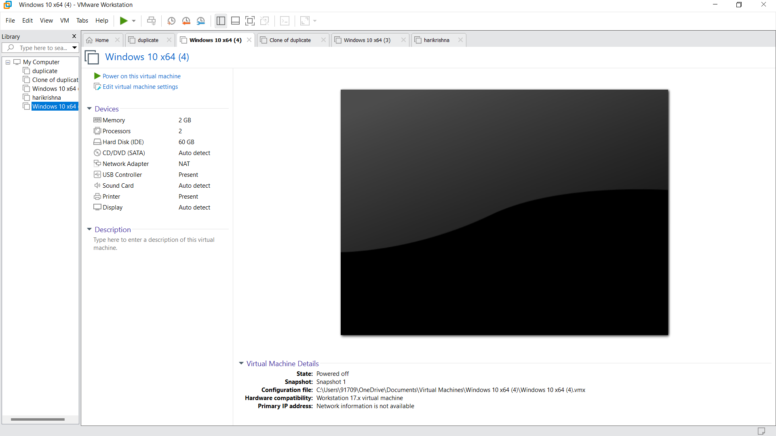

1. Experiment-4:Demonstrate virtualization by Installing Type-2 Hypervisor in your device, create and configure VM image with a Host Operating system (Either Windows/Linux).

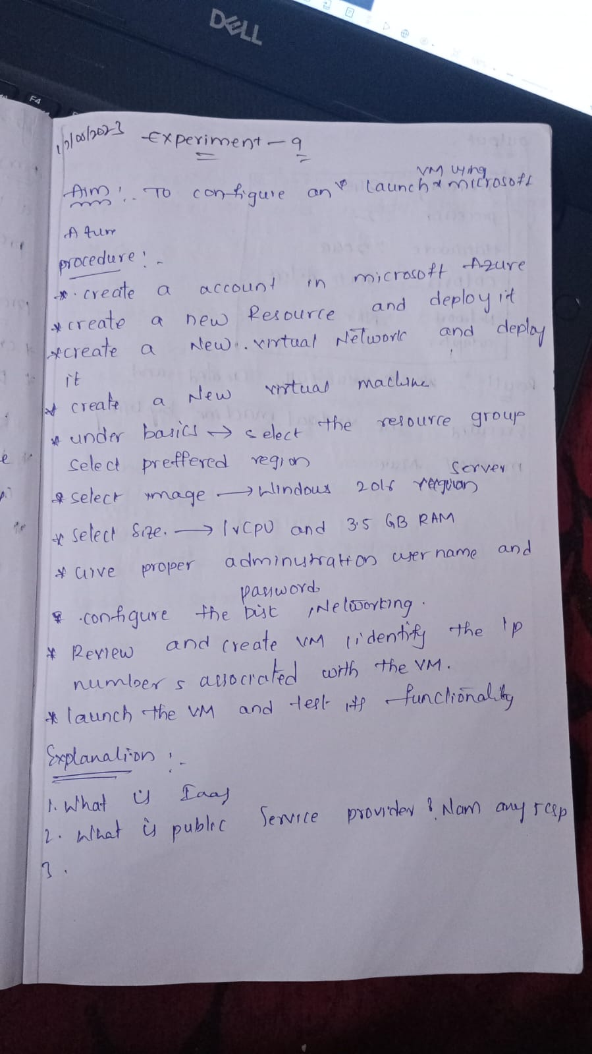

Output:-

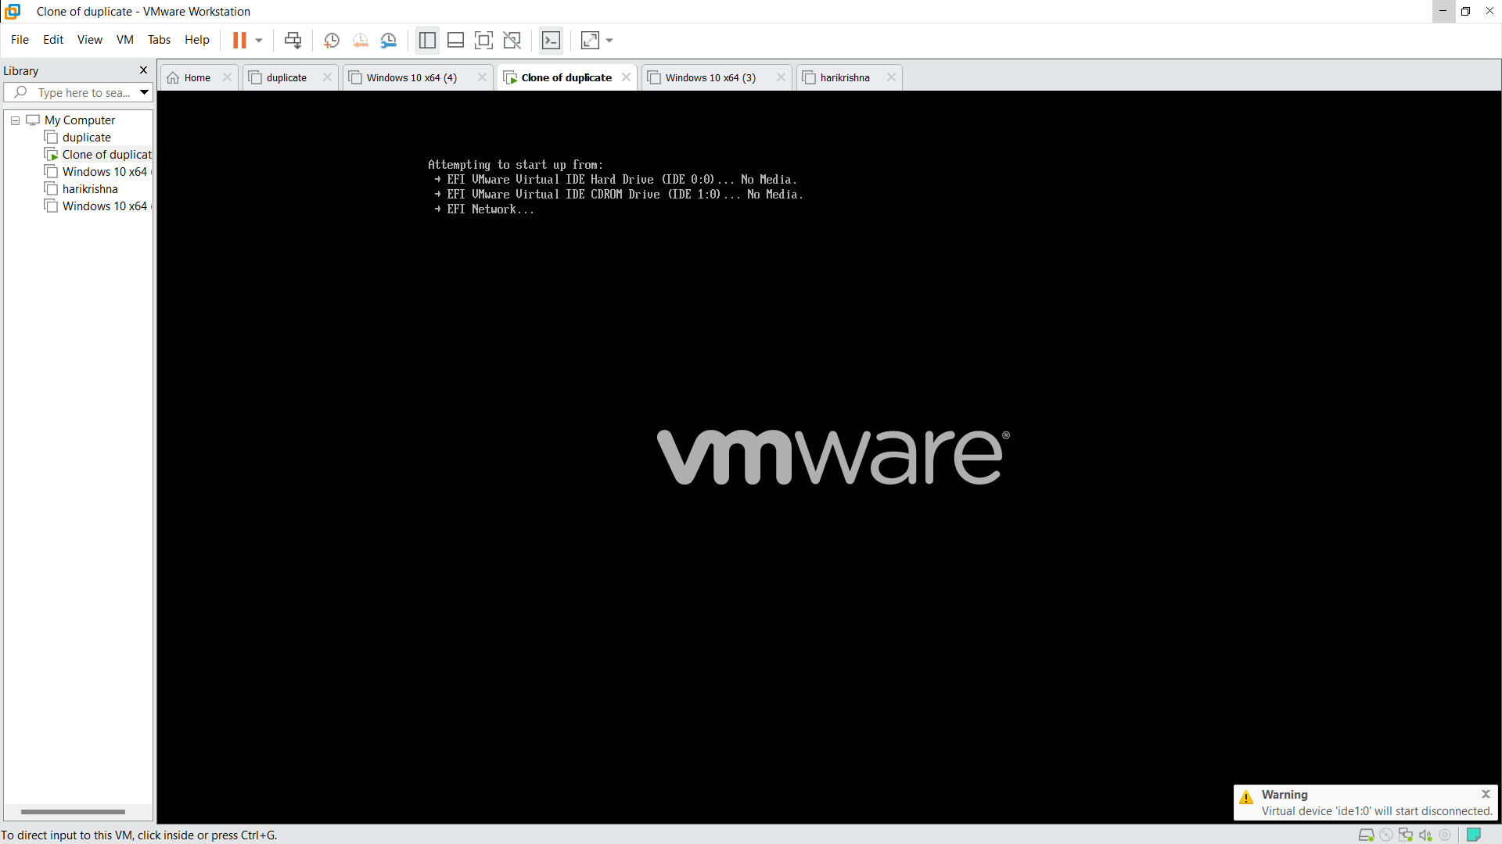

Experiment-5: Change Hardware compatibility of a VM (Either by clone/create new one) which is already created and configured.

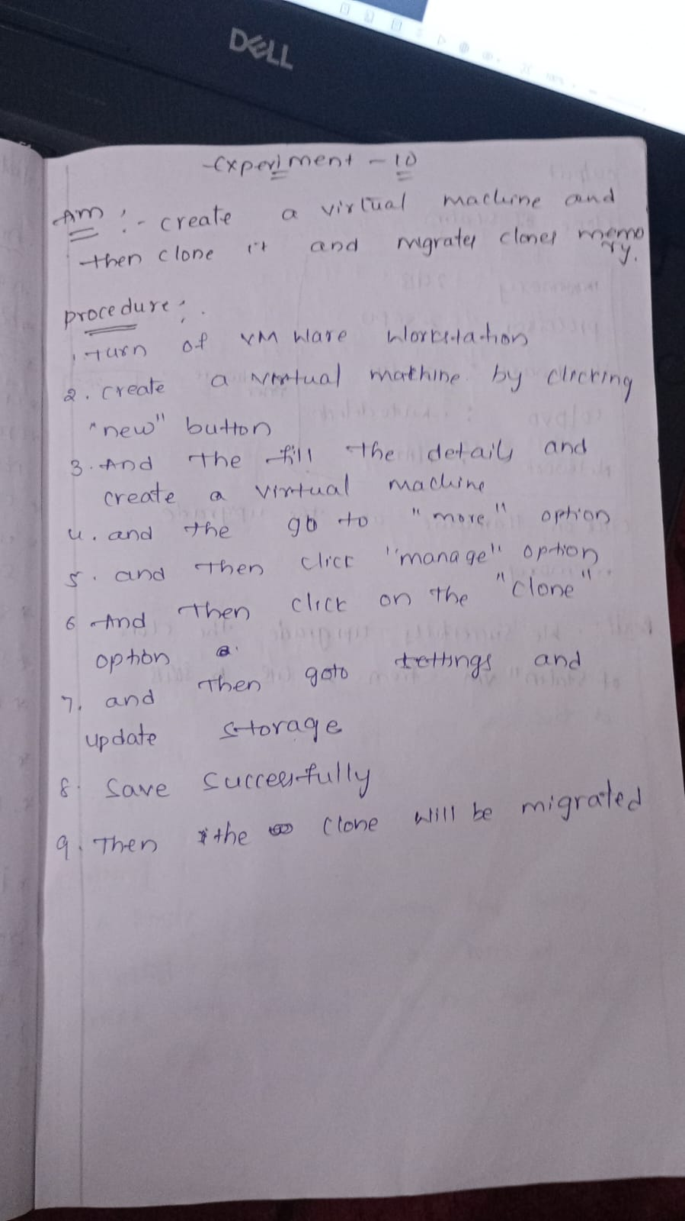

Output:-

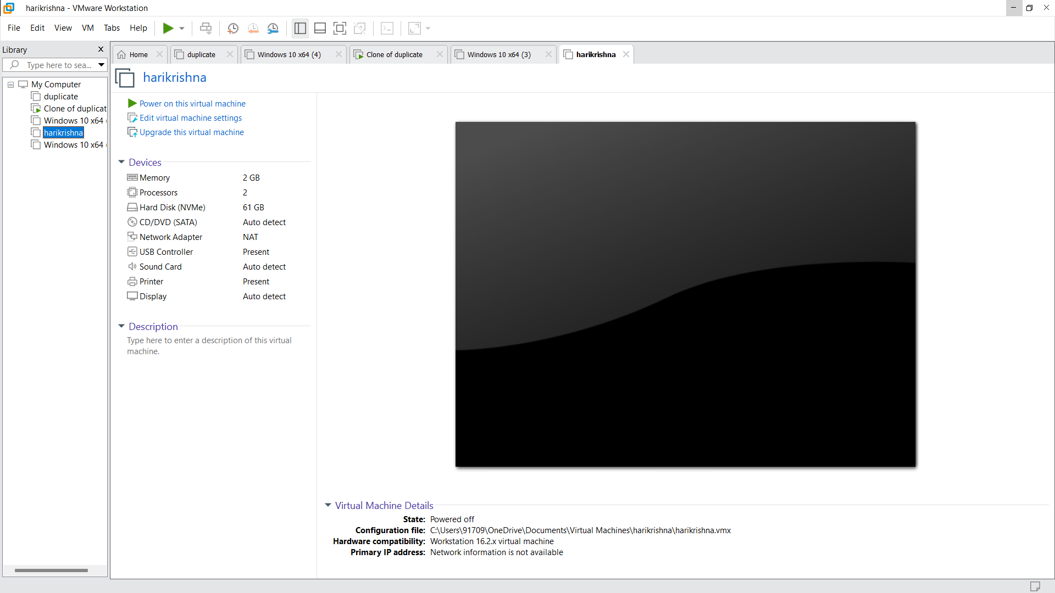

Here change of hardware compatibility workstation 6.0 to workstation 17.0

